Whitewater Rafting Site Plan

# Purpose

To create an immersive and user-friendly online platform that showcases the thrill of whitewater rafting, while providing a seamless experience for customers to plan and book their adventures. The main message is that rafting is a fun activity and to come and experience it for yourself and bring your family.

## Goals

* **Increase Online Visibility**: Establish a strong web presence to attract new customers and increase brand awareness.
* **Showcase Adventures**: Highlight the excitement and beauty of whitewater rafting through engaging visuals, videos, and testimonials.
* **Provide Essential Information**: Offer clear and concise details on trips, pricing, safety guidelines, and company policies.
* **Build Community**: Foster a sense of community among customers and guides through social media integration and customer reviews.
* **Drive Sales**: Convert website visitors into paying customers through targeted promotions, special offers, and loyalty programs.

# Target Audience

* **Demographics**: Adventure-seekers, outdoor enthusiasts, and nature lovers
* **Psychographics**: Individuals seeking excitement, challenge, and connection with nature
* **User personas**: First-time rafters, experienced rafters, families, and corporate groups

## Scenarios

The website should answer the following scenario questions:

* Information on trip levels and difficulty
* Detailed descriptions of what to expect during the trip
* Testimonials and reviews from previous customers
* Information on family-friendly trips and age restrictions
* Details on safety measures and equipment provided
* Options for booking a private guide or group trip
* Recommendations for nearby activities and attractions for non-rafters
* High-quality photos and videos showcasing the trip
* Options for customizing the trip (e.g., private guides, camping)

# Site Map

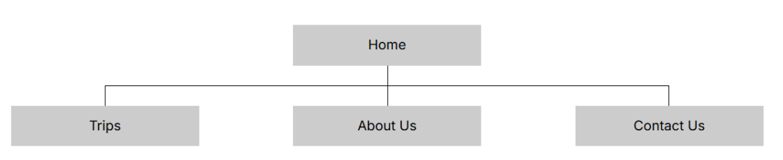

# Branding

## Logo

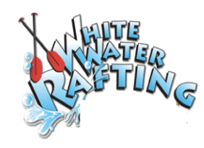

# Style Guide

## Color Schema

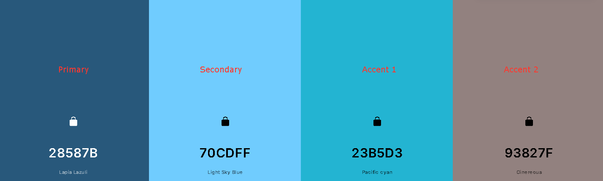

## Typography

### Headings: Trade Winds 400, 700

### Body: Mystery Quest